**Experiment No. 6**

1. **Aim/Overview of the practical:**

Create a logic app in Azure Portal.

1. **Code for practical:**

* Sign in to Azure Portal and click on More Services>Logic App.
* Click on Create a new Logic app.
* Enter the name and select plan to Consumption.

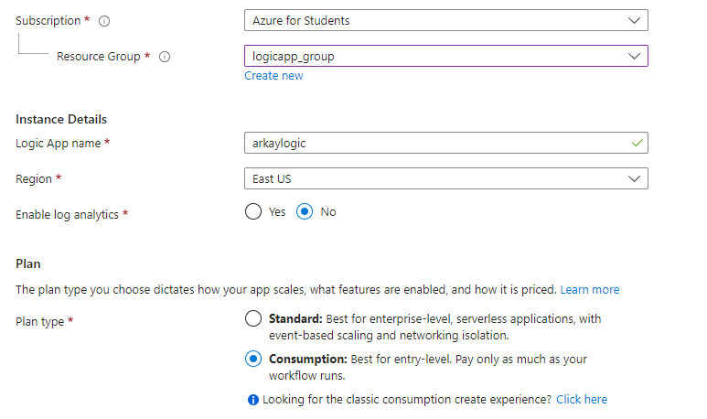

* Click on Review+Create button.
* Your Logic app will be created in few moments.
* Now open Google Drive and create a folder of your name.
* Then, open One Drive and create a folder of your UID.
* Now open your resource on Azure portal and click on Blank Logic App.

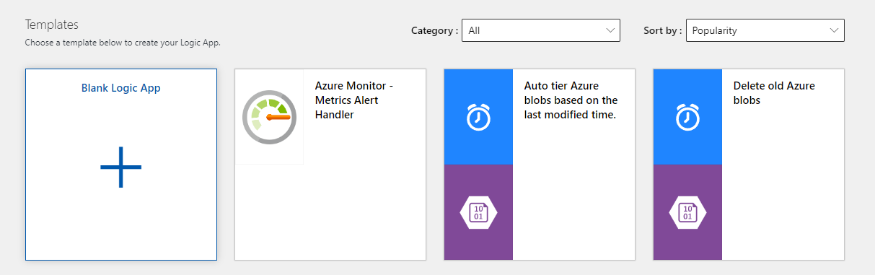

* Click on One drive and Sign in with your account.

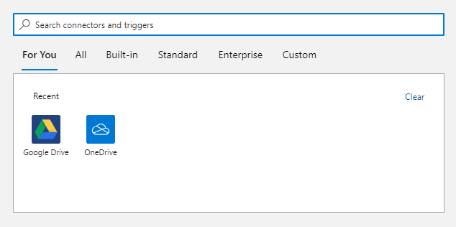

* Now select when a file is created option.

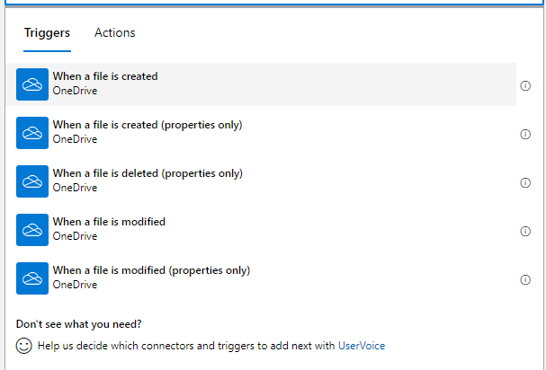

* Select the created folder and time for updating files.

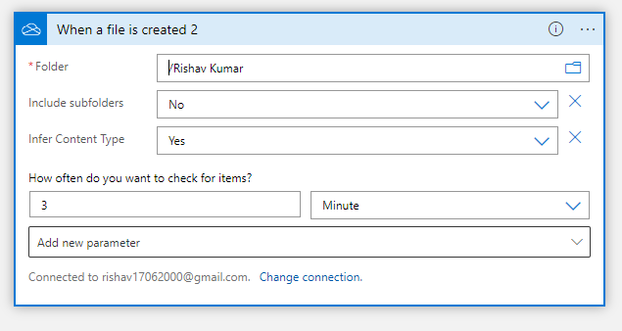

* Now Click on next step and select create new file.
* Select folder of your UID and select name and content for your file.

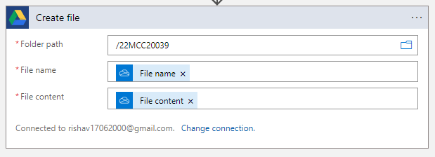

* Click on run trigger.
* Then open One Drive and upload any file in your folder, Your file will be updated in google drive folder.

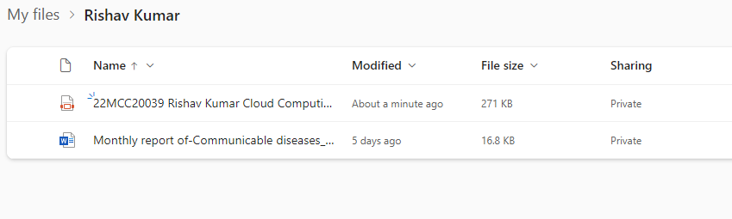

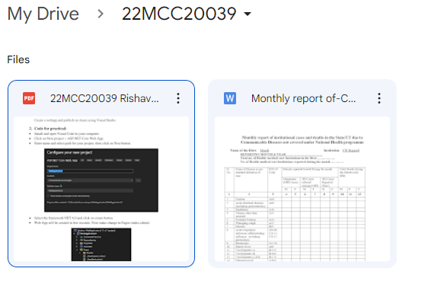

**************************************** **THE END** ***********************************************